Ideation Phase
Brainstorm & Idea Prioritization Template

Date | 03 October 2026
Team ID | SWTID-2026-6867
Project Name | Streamlining IT Procurement: Automating Standard Laptop Orders with Flow Designer
Maximum Marks | 4 Marks

Brainstorm & Idea Prioritization:
The “Streamlining IT Procurement: Automating Standard Laptop Orders with Flow Designer” project focuses on improving the standard laptop procurement process in ServiceNow. The main idea is to use ServiceNow Flow Designer to automate the activities involved in processing standard laptop requests. When a user submits a laptop request through the Service Catalog and the request is approved, the flow automatically creates a Catalog Task and assigns it to the Hardware team for laptop configuration. This reduces manual task creation, improves task assignment, minimizes delays, and ensures that configuration activities are completed on time. By automating these activities, the project helps improve IT procurement efficiency, reduce manual effort, and provide users with a smoother laptop ordering experience.
Step-1: Team Gathering, Collaboration and Select the Problem Statement
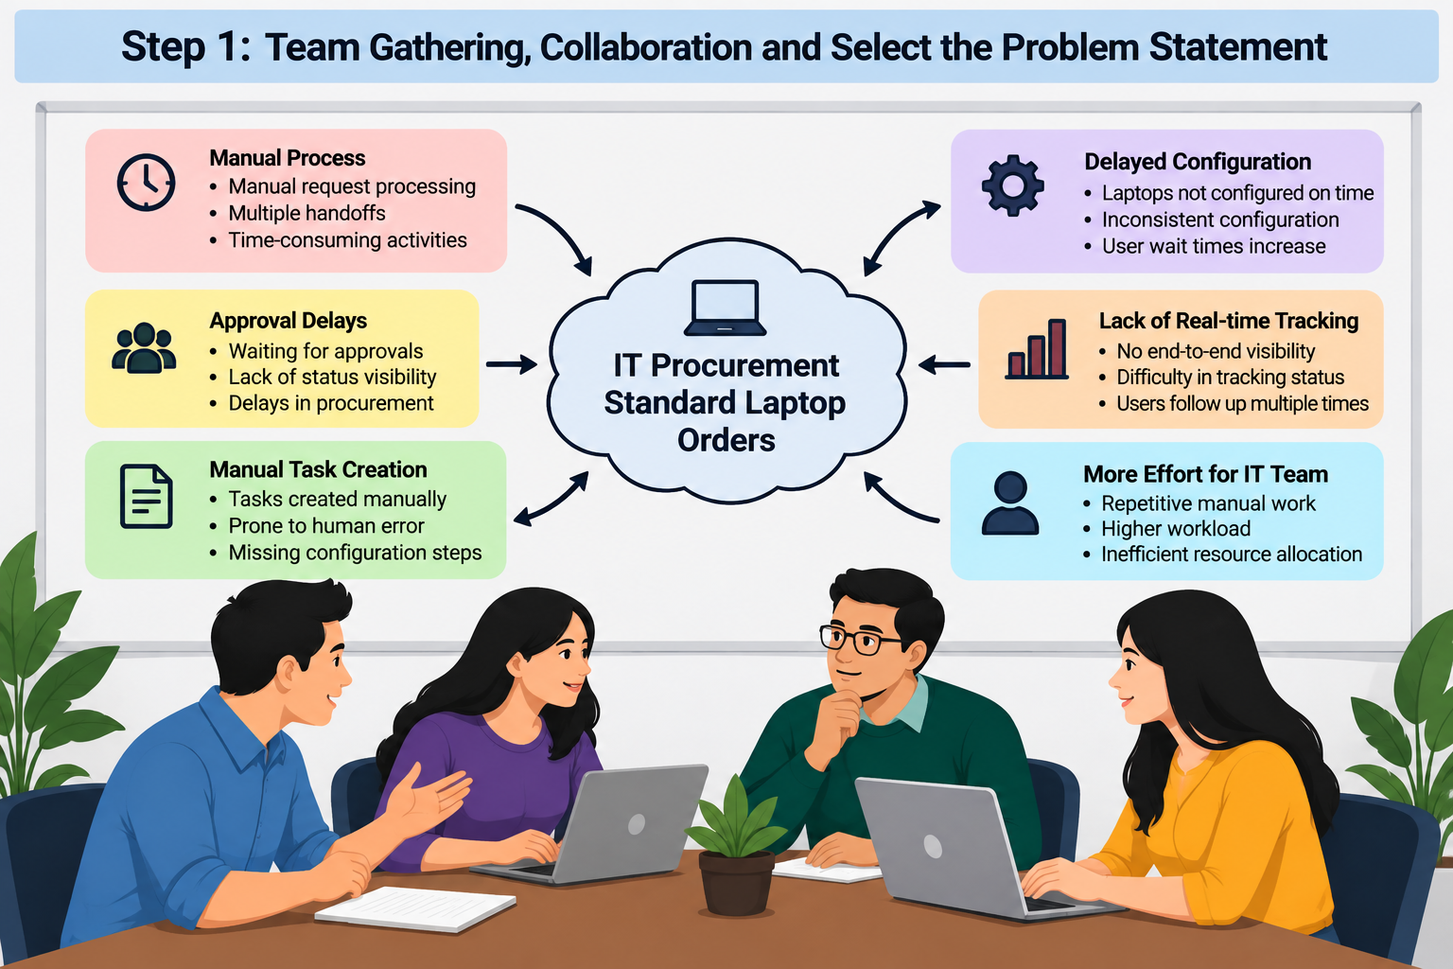
How Might We: “How might we automate standard laptop orders so that approved requests automatically create and assign configuration tasks to the Hardware team?”

Step-2: Brainstorm, Idea Listing and Grouping
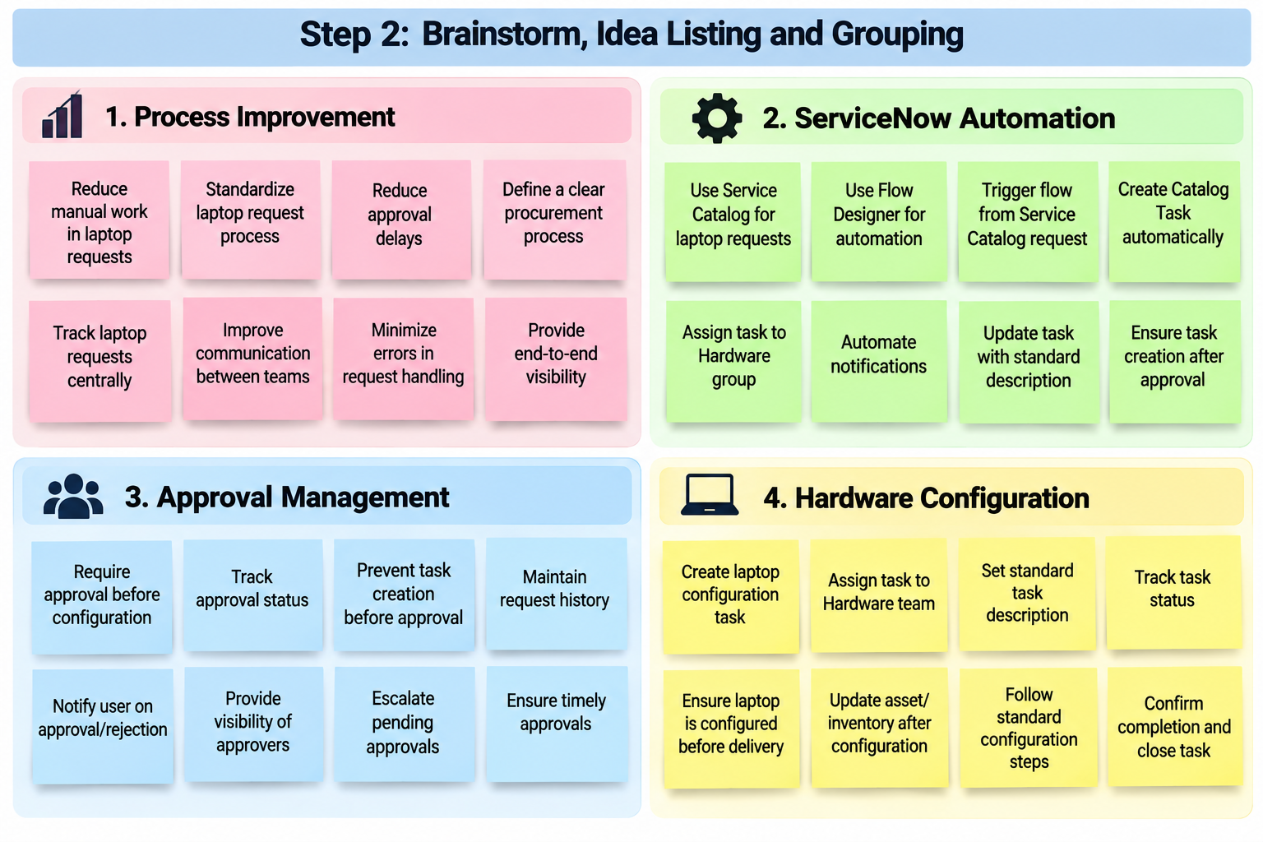
Step-3: Idea Prioritization
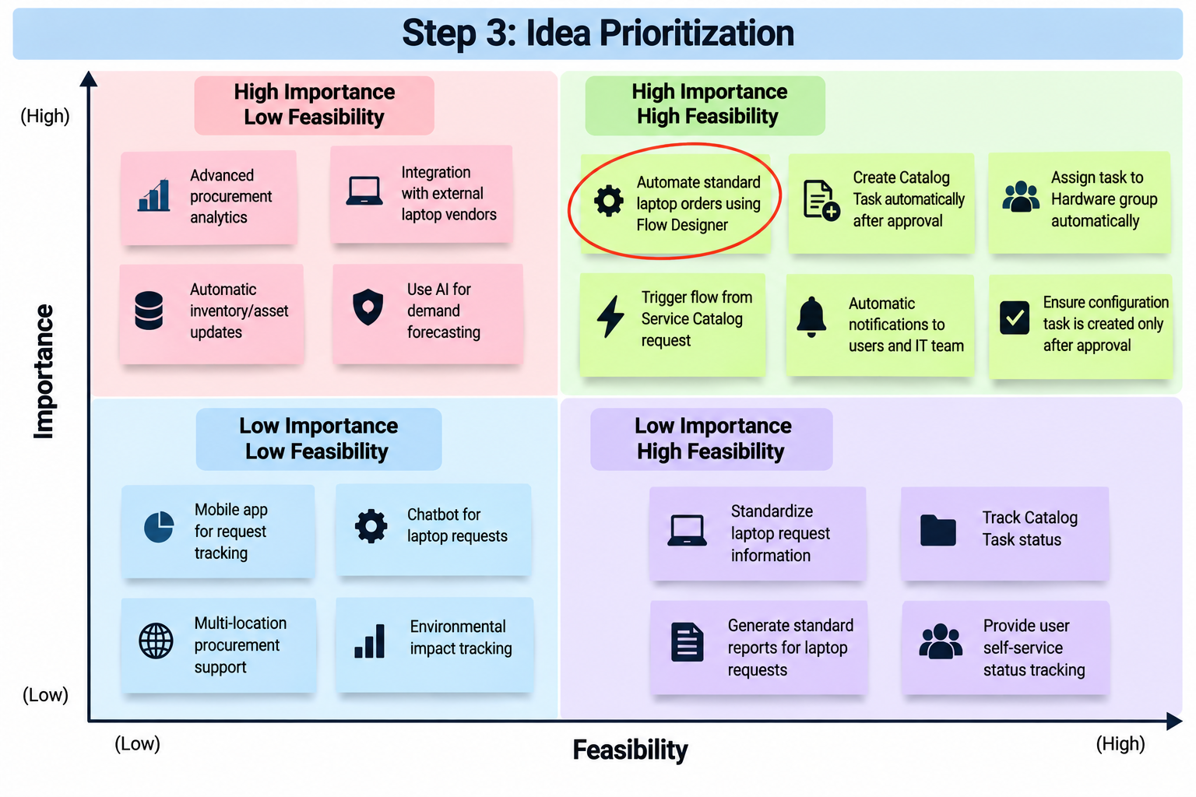
Selected Idea: “Automate Standard Laptop Orders using ServiceNow Flow Designer”

